**CHANDIGARH UNIVERSITY**

**UNIVERSITY INSTITUTE OF ENGINEERING**

**DEPARTMENT OF COMPUTER SCIENCE AND ENGINEERING**



|  |  |
| --- | --- |
| **Submitted by:** | **Submitted To:**  Er. Bhupinder Singh (12856) |
| **Subject Name:** | Multimedia Technologies Lab |
| **Subject Code:** | 20CSP-339 |
| **Branch:** | CSE |
| **Semester:** | 5th |

LAB INDEX

|  |  |  |  |  |  |  |  |
| --- | --- | --- | --- | --- | --- | --- | --- |
| **Sr.No** | **Program** | **Date** | **Evaluation** | | | | **Sign** |
| **LW(12)** | **VV(8)** | **FW(10)** | **Total (30)** |
|  |  |  |  |  |  |  |  |
|  |  |  |  |  |  |  |  |
|  |  |  |  |  |  |  |  |
|  |  |  |  |  |  |  |  |
|  |  |  |  |  |  |  |  |
|  |  |  |  |  |  |  |  |
|  |  |  |  |  |  |  |  |
|  |  |  |  |  |  |  |  |

**Experiment 5**

**Student Name: Yash Gupta UID: 20BCS5009**

**Branch: BE-CSE Section/Group: 20BCS-MM-806 A**

**Semester: 5 Date of Performance: 29-09-2022**

**Subject Name: MMT LAB Subject Code:**

**Aim :-** You are given a picture of a garden as background. Extract the image of a butterfly from another picture and organize it on the background using Adobe photoshop

**Hardware Requirements: -** Minimum 384MB RAM, 100 GB hard Disk, processor with 2.1 MHz

**Software Requirements: -** Adobe Photoshop, Photopea

**Tools to be used:** Type Tool, Magic Wand, Lasso select

**Steps 1 :-** Create the new project and set the dimensions according to the requirement.

**Steps 2 :-** Now you have to select the given background image. You can take image through various methods.

1. If the image is in your system, then you can take it from FILE ---> Open and place.

2. You can do copy the image and paste it on the template.

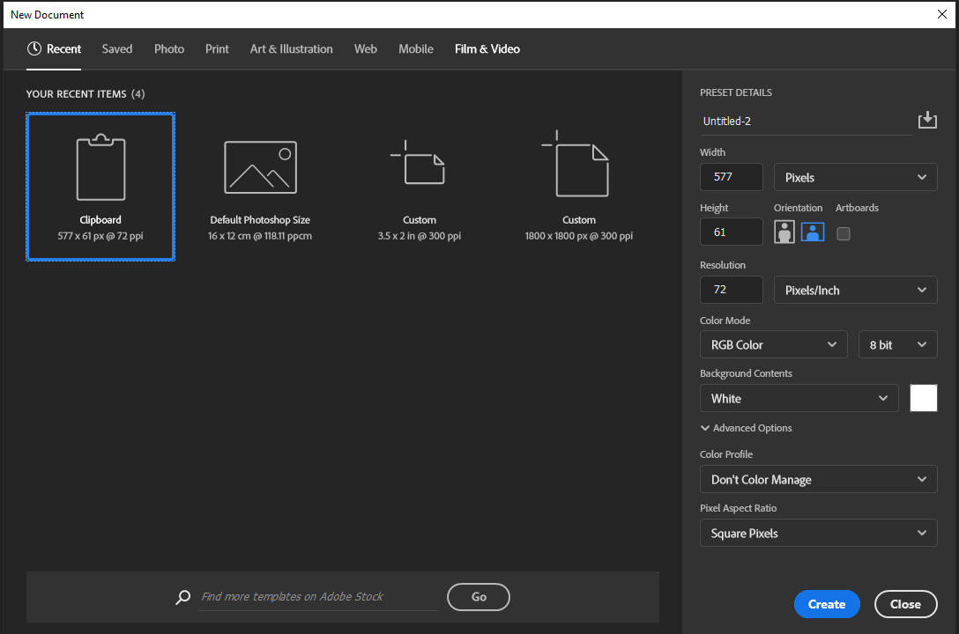

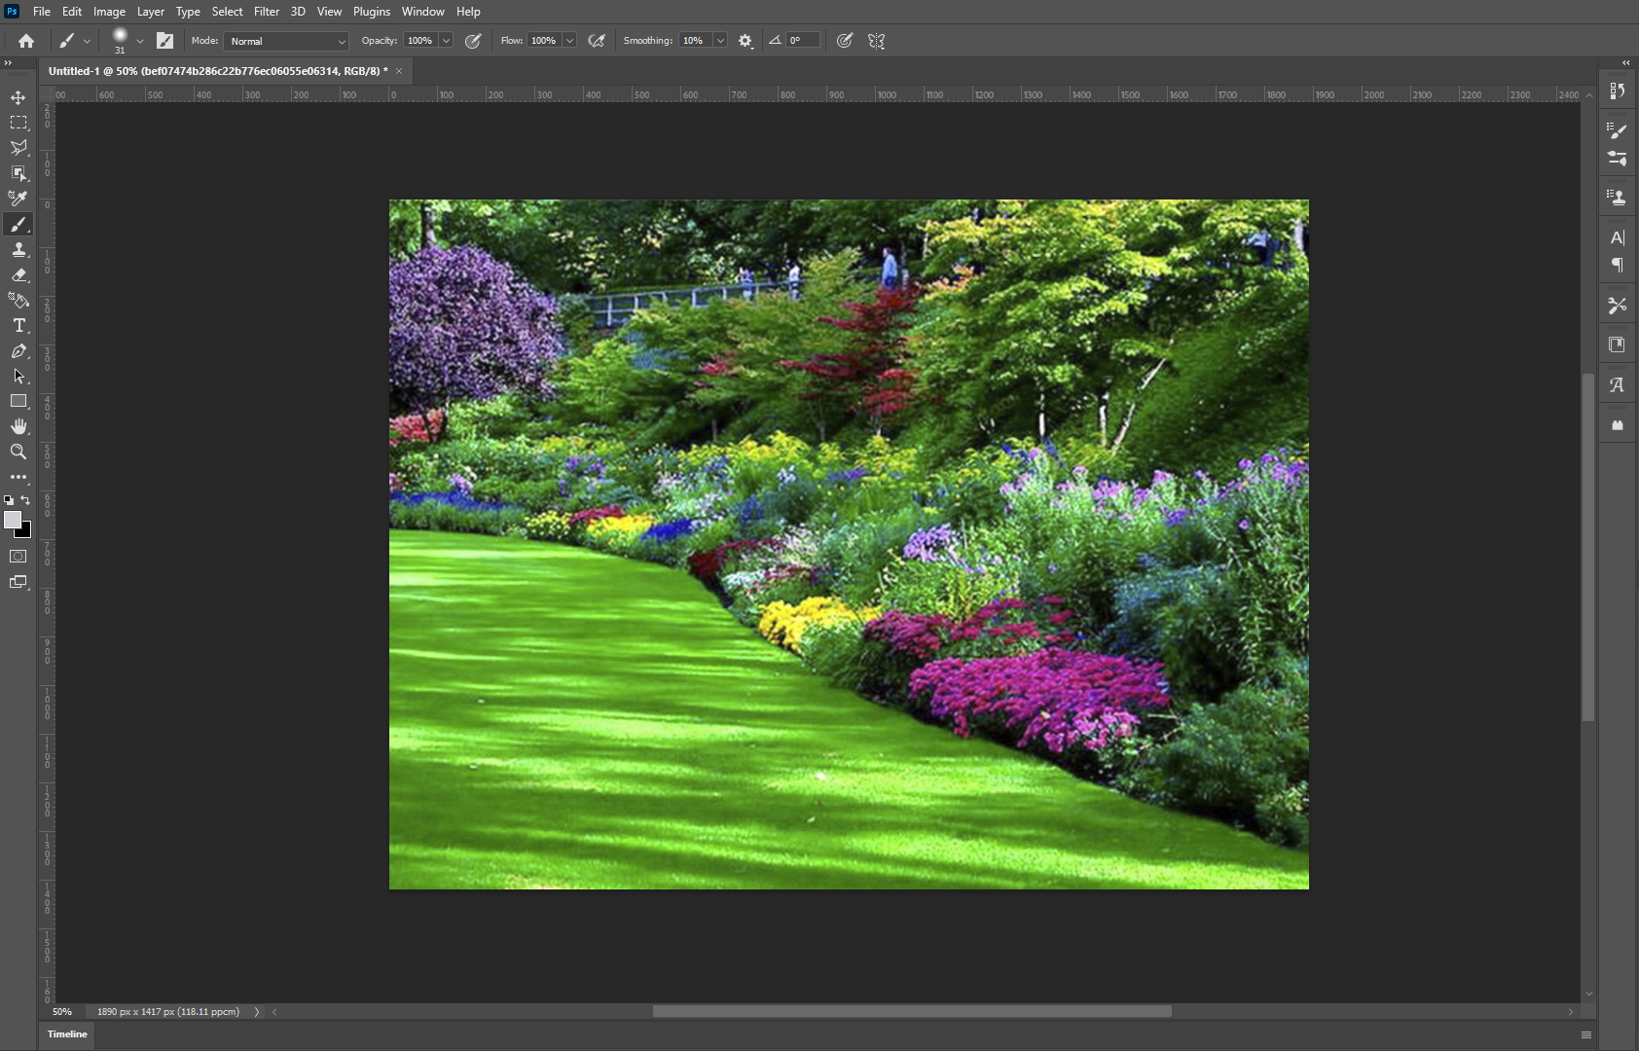

**Step3:-** After that we need to take buttery picture from another picture. For that you can follow the same step- 2.

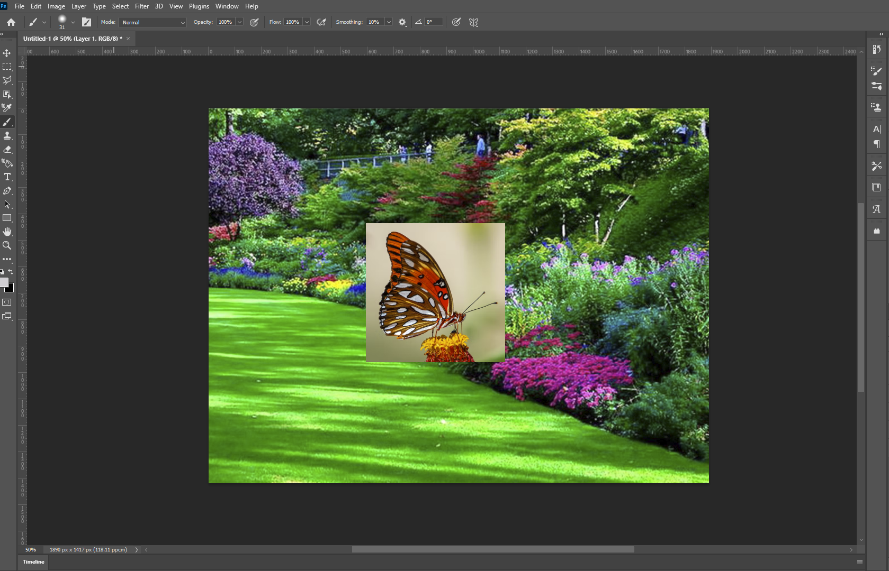

**Step4:**- For extracting the butterfly from the image you need to select the **Magic Wand** tool.

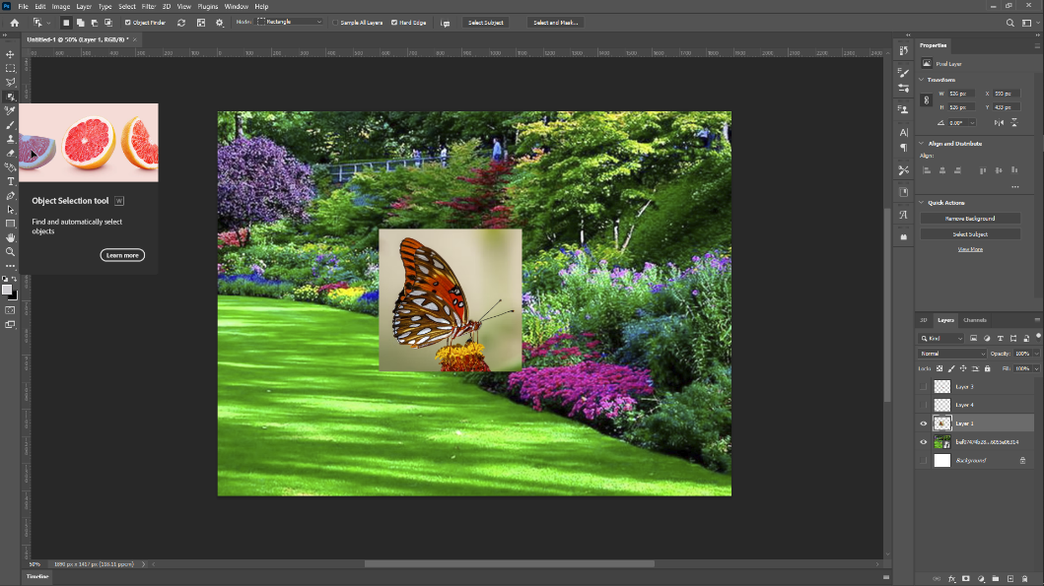

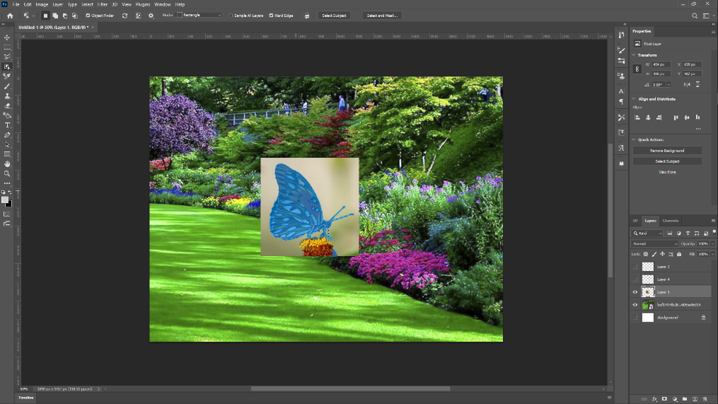

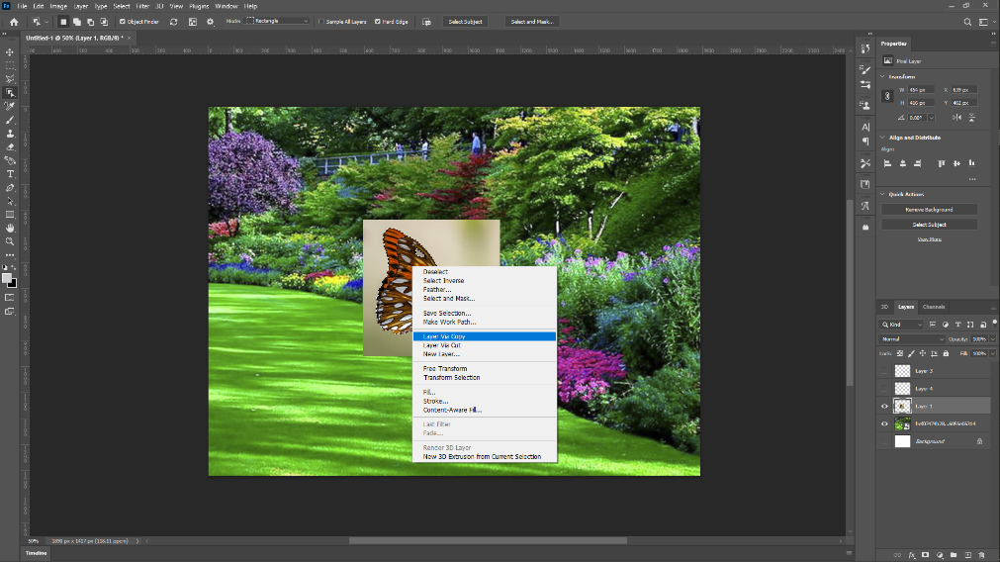

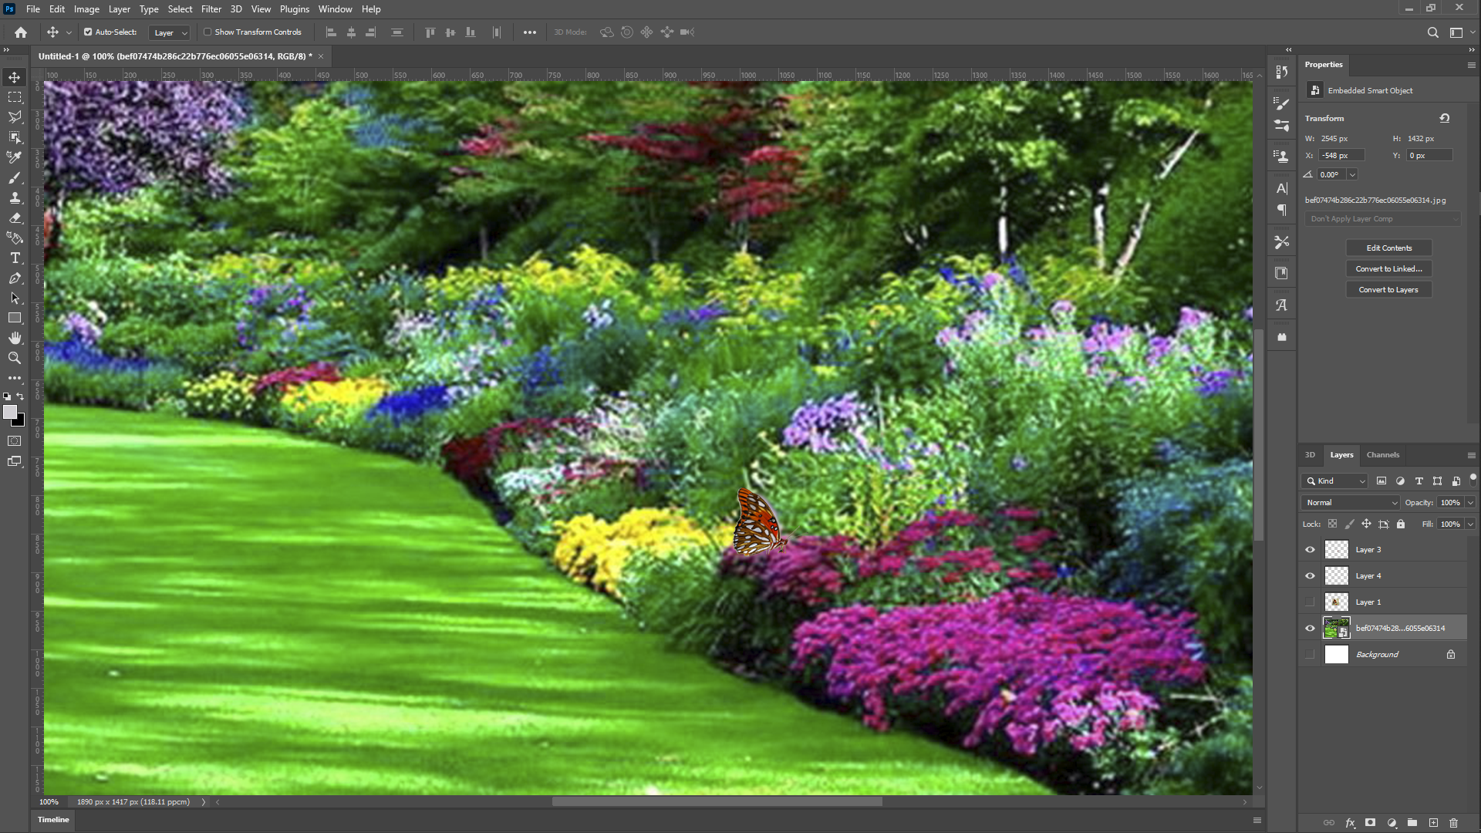

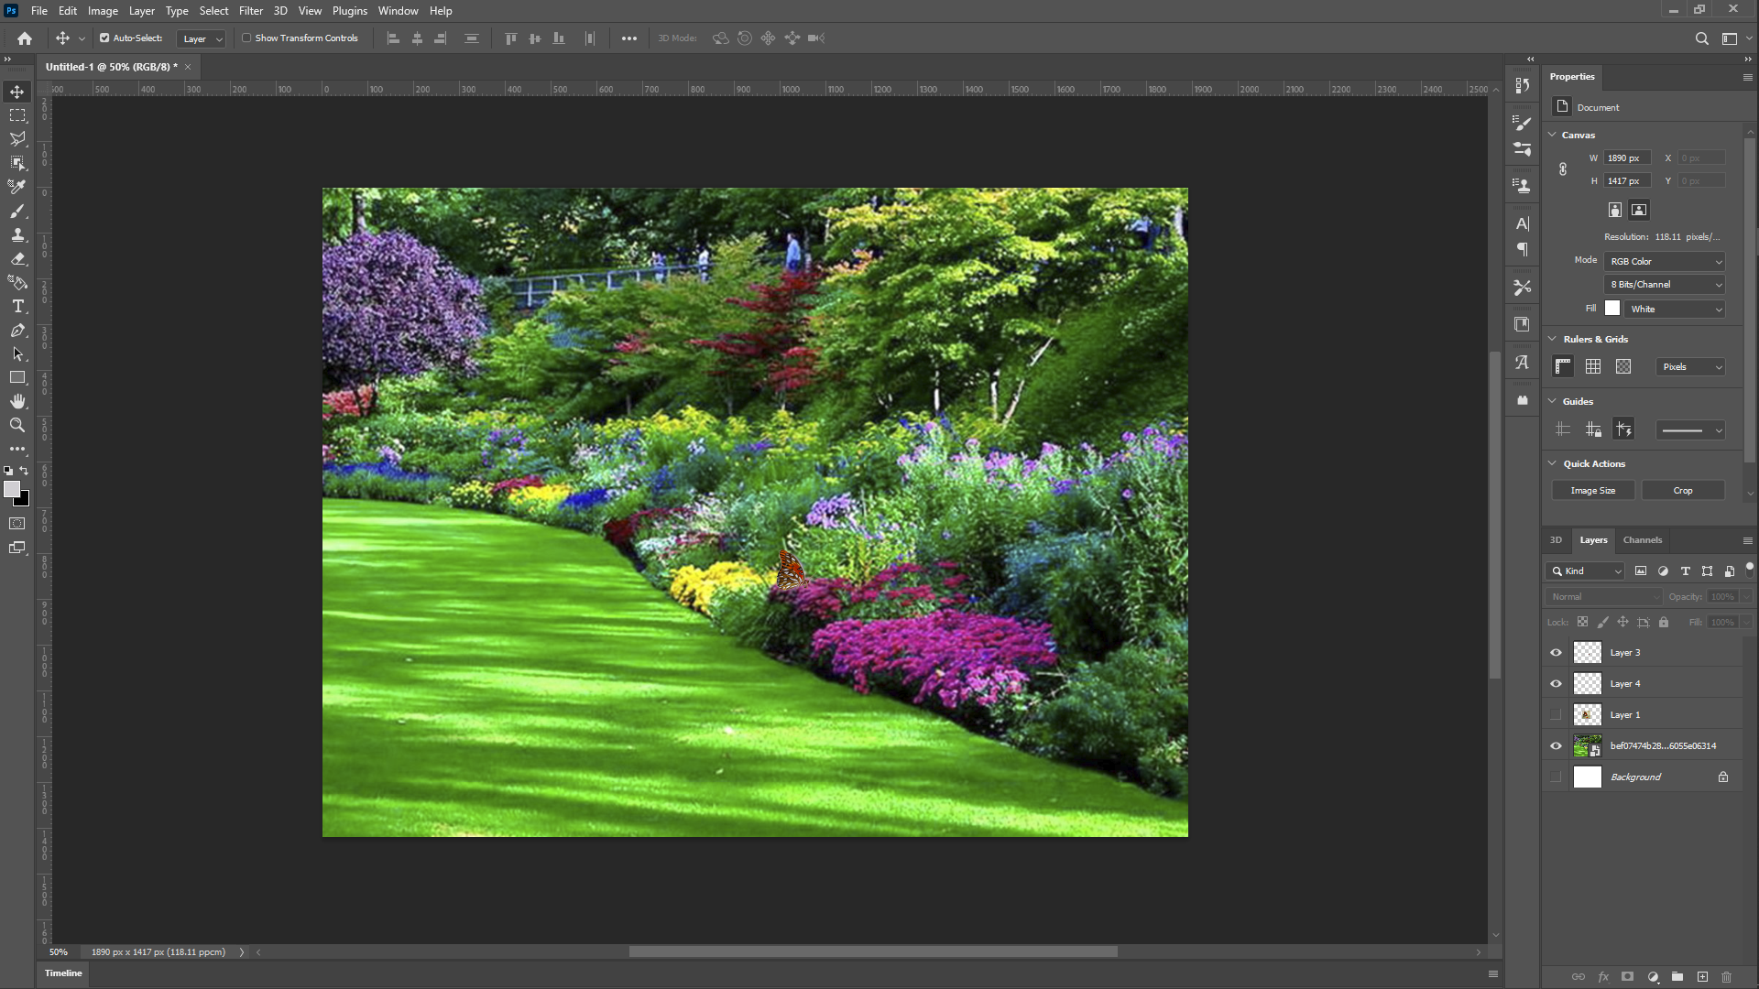

**Evaluation Grid (To be created as per the SOP and Assessment guidelines by the faculty):**

|  |  |  |  |
| --- | --- | --- | --- |
| Sr. No. | Parameters | Marks Obtained | Maximum Marks |
| 1. |  |  |  |
| 2. |  |  |  |
| 3. |  |  |  |
|  |  |  |  |